Language, Literacy and Communication  Oracy: Show and tell. Talk for writing learning stories and facts.  Reading: Shared, guided and individual. High Frequency words. Green and red words. Dictionary work. Reading eggs. Shared reading and guided reading groups. SPAG adjectives, adverbs, simple roots, plurals, correct tense past, present and future.  Writing Researching facts and writing descriptive sentences about dangerous creatures, caterpillars and butterflies, Lions, Elephants and Giraffes. Caterpillar diaries Year 2. Character and setting descriptions from the Savannah, Rainforest and beach. Layers of the rainforest, plant and animal adaptions and weather reports. Pirate stories.  Handwriting consistent size and proportion. 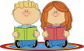  Welsh  Oracy: Helpwr Heddiw. Incidental Welsh. Drillio. Siart tywydd. Past tense Es I Ces I....  Reading: Tedi Twt a Doli Glwt. Fflic a Fflac.  Writing: Dwi’n hoffi book review. Es i ces i Postcard past tense. Beth sy’n bod? Sgwrs.  Digital Competence: Seesaw. E-mail. Green Screen. Puppet pals Welsh Sgwrs | Go Wild!  Year 3/2  Mrs Thomas / Mrs Evans  Summer Term 2023 | 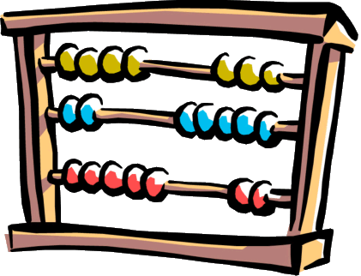  Mathematics and Numeracy  Counting in 2s, 5s and 10s (3s and 4s)  Number bonds to 10 20 100.  Missing number sums.  Money – making amounts to 50p/£1.00. £2 / £10 Giving change with multiples of 10.  Time – analogue and digital.  Multiplication and Division  Fractions of shapes and amounts including halves, quarters and thirds  Length and perimeter  Digital Competence: JIT chart. Beebot. Online maths games. Maths apps.
Expressive Arts
Art: 3D sculpture of human and physical features of the locality.
Music: Pbuzz. Singing songs about Spring and Summer and listening, singing and responding to ‘Let your spirit fly’ on Charanga. Playing instruments to accompany the song.
Drama: Hot seating characters from A new home for a pirate’ and acting out scenes to write about.
Film: Watching and responding to the short film ‘The Lighthouse’ and discussing the different camera angles used.
Real PE. Outdoor games. Sports day practice.
Science and Technology  Science: Electricity and its uses. Make electric circuits and draw them using symbols. Mini experiments: Giving wings to our own butterflies; Mentos and coke; Alka-Seltzer and water which goes the furthest.  Ecosystems: Variation and evolution – how animals adapt to the environment.  Forces: Pushes and pulls pulley transporting Mr Grinling’s lunch. Launching a lifeboat / boat friction experiment. Floating and sinking experiments.  Design Technology: Design and make local landmarks using papier mache/recycled materials  Digital Competence: JIT mix, chart. Green Screen. | Humanities  Signs of Spring and Summer  Forest School.  Digital Competence: Beebot/ JIT turtle. Hwb  Beach trip Bracelet Bay to look at landscape physical and human features of the locality.  Inspiration for the art project.  Big apple, Lighthouse, Pier and Lifeboat station.  Bird’s eye view plan. | 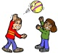  Health and Well Being  PE: Ball skills: ball chasing, ball handling, sending and receiving, strike tennis, relay games. Hockey and football skills. Floor work: static balance. Reflection on their skill development. Effects of physical activity on their bodies. Sports day.  Well Being: Families and relationships. Sense of belonging. Explore communities they may belong to and how to access support within their communities. Begin to understand respect and empathy. Causes and effects of a conflict in their community. Circle time. Social stories. Forest School. Role play and small world play.  RRS: Class charter and Right of the month.  Digital Competence: Green Screen, J2 Launch (camera/ video). E-safety.

