Language, Literacy and Communication  Oracy: Show and tell research their favourite animal. Talk for writing learning stories and facts.  Reading: Shared, guided and individual. High Frequency words. Green and red words. Dictionary work. Reading eggs.  Writing Easter News. Spring & Summer senses poem. Researching facts and writing descriptive sentences about dangerous creatures/animals. Character and setting descriptions from the Savannah, Rainforest and beach. Layers of the rainforest, plant and animal adaptions and weather reports. Pirate stories. Handwriting consistent size and proportion.  Welsh  Oracy: Helpwr Heddiw. Incidental Welsh. Drillio. Siart tywydd.  Reading: Tedi Twt a Doli Glwt. Fflic a Fflac.Trich a Chlic.  Writing: Dwi’n hoffi book review.  Beth sy’n bod? Sgwrs.  Digital Competence: Seesaw. E-mail. Green Screen. Puppet pals Welsh Sgwrs | Go Wild!  Year 1  Miss Tyrrell  Summer Term 2023 | 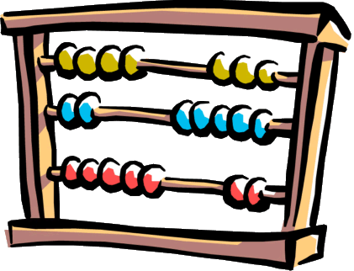  Mathematics and Numeracy  Counting in 2s, 5s and 10s. Doubles and halves.  Number bonds to 10 20 100.  Missing number sums.  Money – making amounts and recognising coins to £2.  Time – analogue and digital. O’clock and half past.  Fractions of shapes  Reinforce read write and order numbers to 100  Number bonds to 10,20,100.  Addition and subtraction.  Odd and even  Digital Competence: JIT chart. Beebot. Online maths games. Maths apps.
Expressive Arts

Art: 3D sculpture of human and physical features of the locality.
Music: Singing songs about Spring and Summer and listening, singing and responding to ‘Let your spirit fly’ on Charanga. Playing instruments to accompany the song.
Drama: Hot seating characters from A new home for a pirate’ and acting out scenes to write about.
Film: Watching and responding to the short film ‘The Lighthouse’ and discussing the different camera angles used.
Real PE. Outdoor games. Ball skills. Sports day practice.
Science and Technology  Science: Electricity and its uses. Planting and growing investigation.  Ecosystems: Variation and evolution – how animals adapt to the environment.  Forces: Pushes and pulls pulley transporting Mr Grinling’s lunch. Floating and sinking experiments.  Design Technology: Design and make local landmarks using papier mache/recycled materials  Digital Competence: JIT mix, chart. Green Screen. | Humanities  Signs of Spring and Summer  Forest School.  Digital Competence: Beebot/ JIT turtle. Hwb  Beach trip Bracelet Bay to look at landscape physical and human features of the locality.  Inspiration for the art project.  Big apple, Lighthouse, Pier and Lifeboat station.  The beach now and then.  Bird’s eye view plan. | 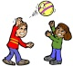  Health and Well Being  PSE  To know and respect that not all families are the same /  To know there are different relationships beyond friends and family e.g., doctor, teachers, pets, coaches etc.  Well Being: Sun safety. Emotional literacy. Circle time. Stories with morals. Social stories. Forest School. Role play and small world play.  RRS: Class charter and Right of the month. Class assembly.  Digital Competence: Green Screen, J2 Launch (camera/ video). E-safety.

